1. Creating and Renaming Files/Directories

- mkdir to create a new directory.
- ls to check list of files in current directory.
- cd to change directory.
- Pwd to print working directory
- touch command to create a new empty file.
- Mv command to change the file name from old to new.

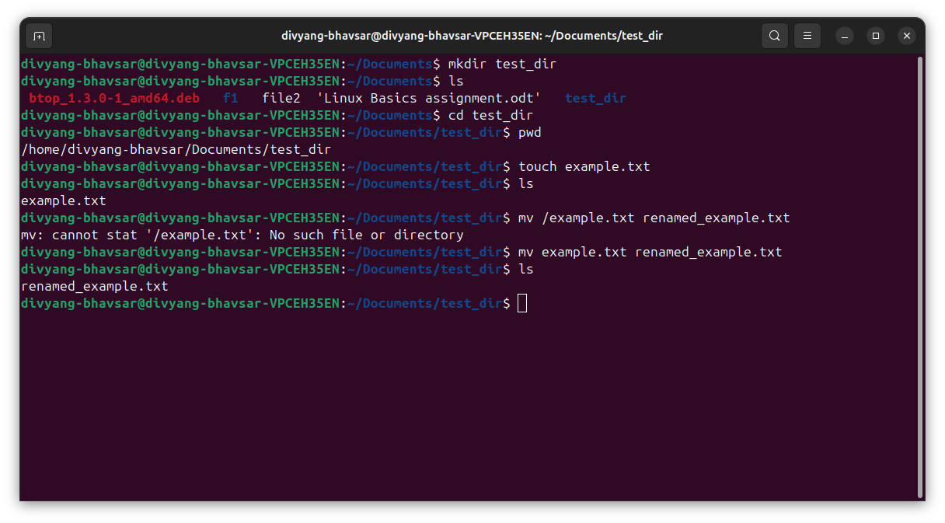

2. Viewing File Contents

- cat command to see the inside file content.
- Head command to get 5 lines of the content inside file.
- Head command to get last 5 lines of the content inside file.

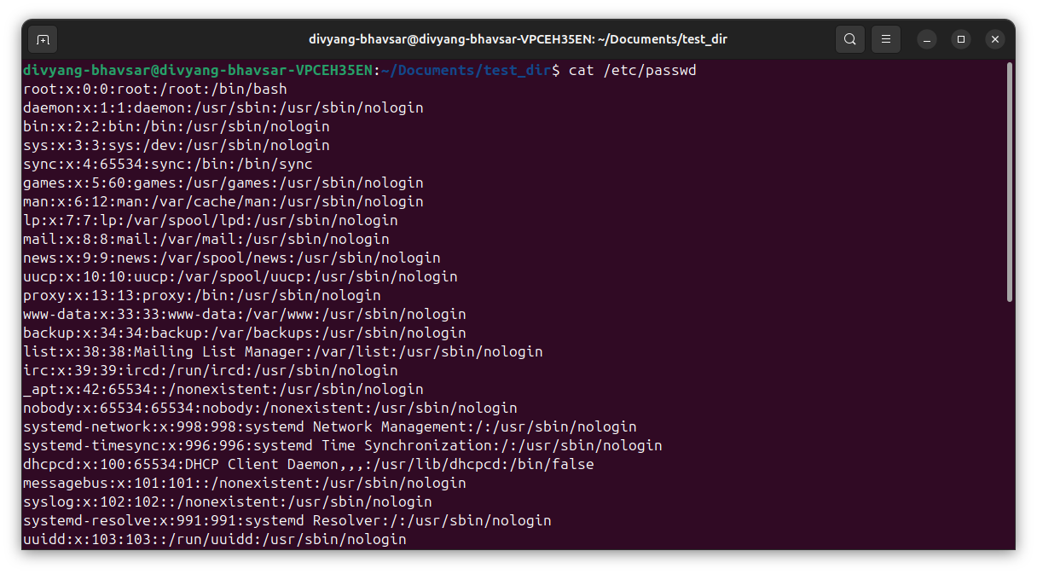

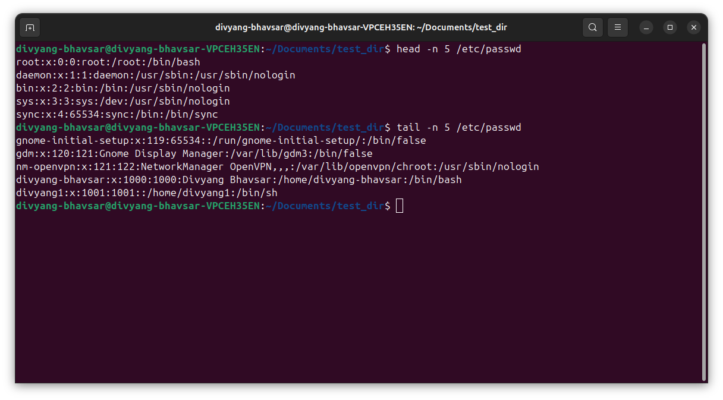

3.Searching for Patterns

- grep command is used to search for the text patterns.
- Here I have search the content with (-n) attributes it will show line numbers with matches.

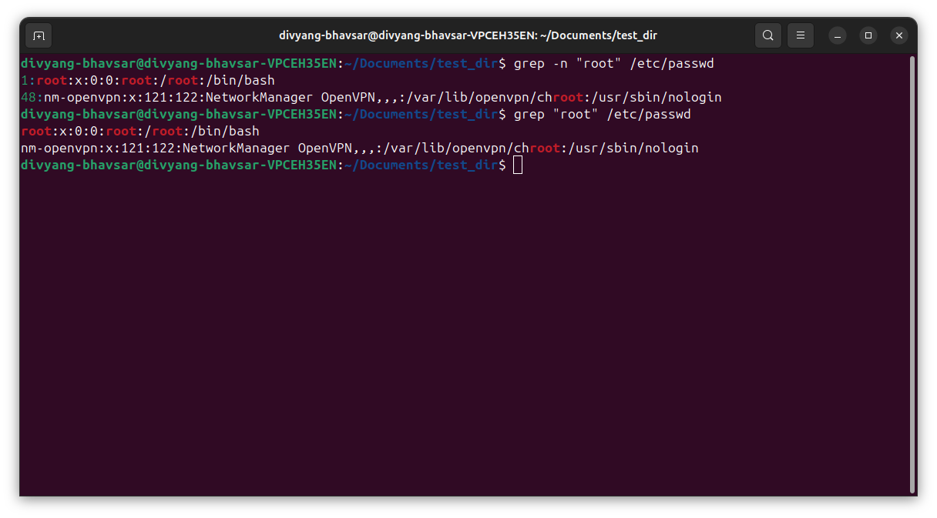

4. Zipping and Unzipping

- gzip command is use for zip the single file.
- If we need to compress folder then tar -cvf (create verbose file)command will use with gzip command as per the below snapshots.

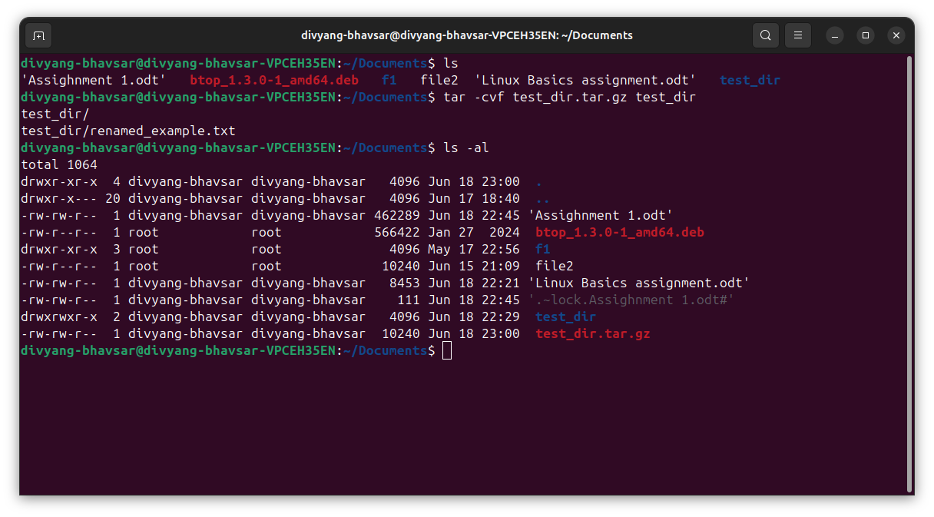

- If we need to unzip folder then use tar -xvf (extract verbose file)command will use with gunzip command as per the below snapshots.
- (tar -xvf test_dir.tar > unzipped_dir ) to Unzip test_dir.zip into a new directory named unzipped_dir.

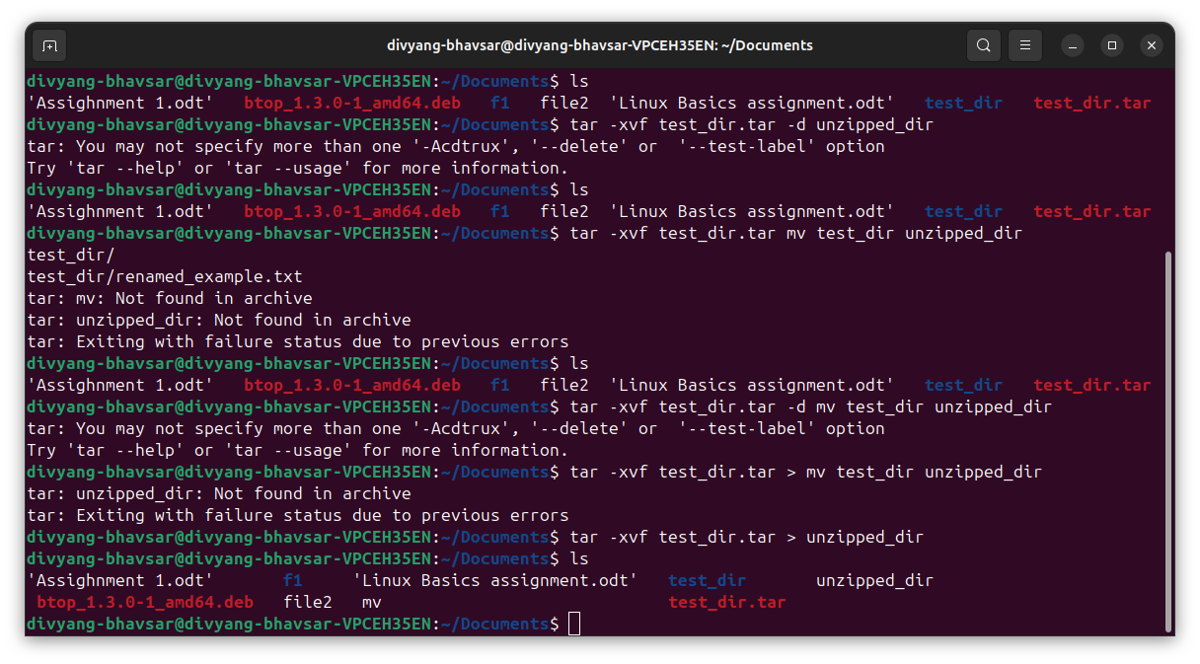

5. Downloading Files

- wget command to download any file from the internet via web link like (https://example.com/sample.txt)

No txt file available on the given link in assignment.

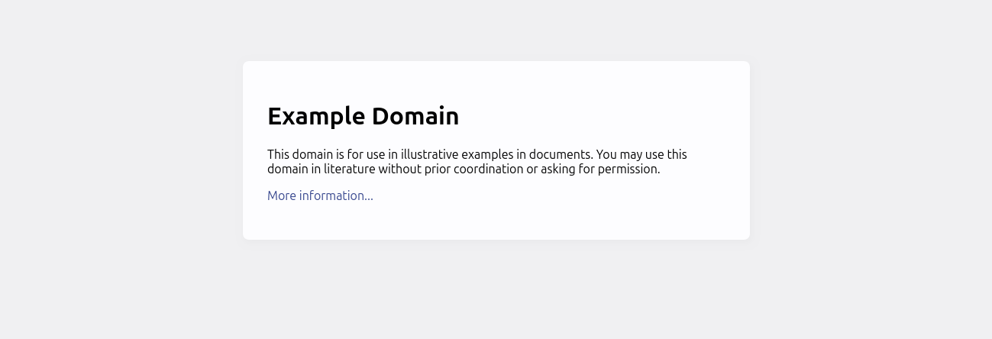

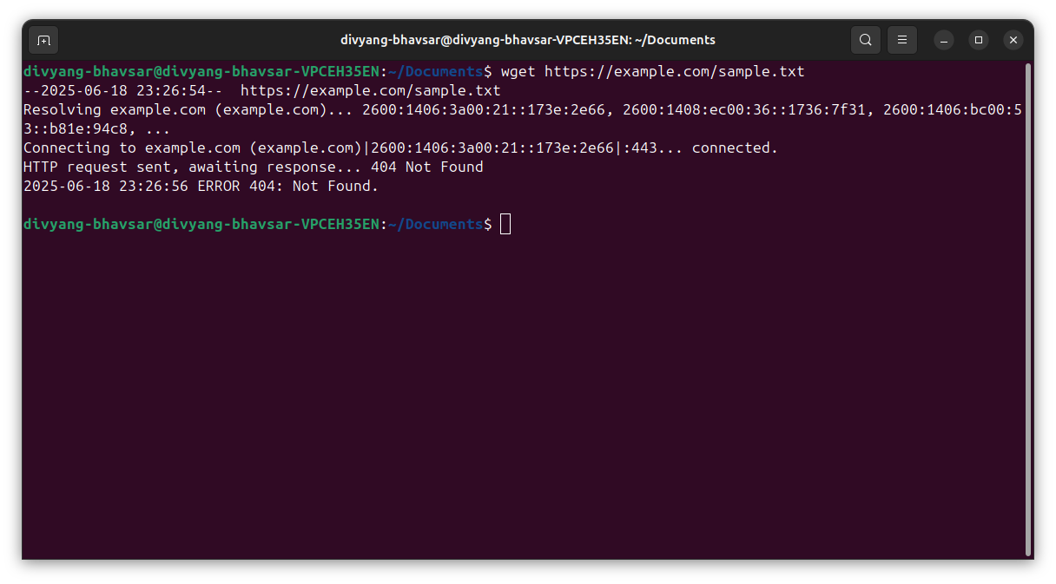
6. Changing Permissions

- We can give the permission with two way one is from numeric value read=4, write=2, executive=1.
- 2 way to give permit ion with char value r=read, w=write & e=execute also we can use the parameter for addition (+r) to add read perdition and (+w) add write and (+e) to add execute permission as we use addition operator for add permission smiler way to we can use omit the permission with (-) operator.
- Here in snapshot I have used (=) operator to give read only permission to all (a) user.

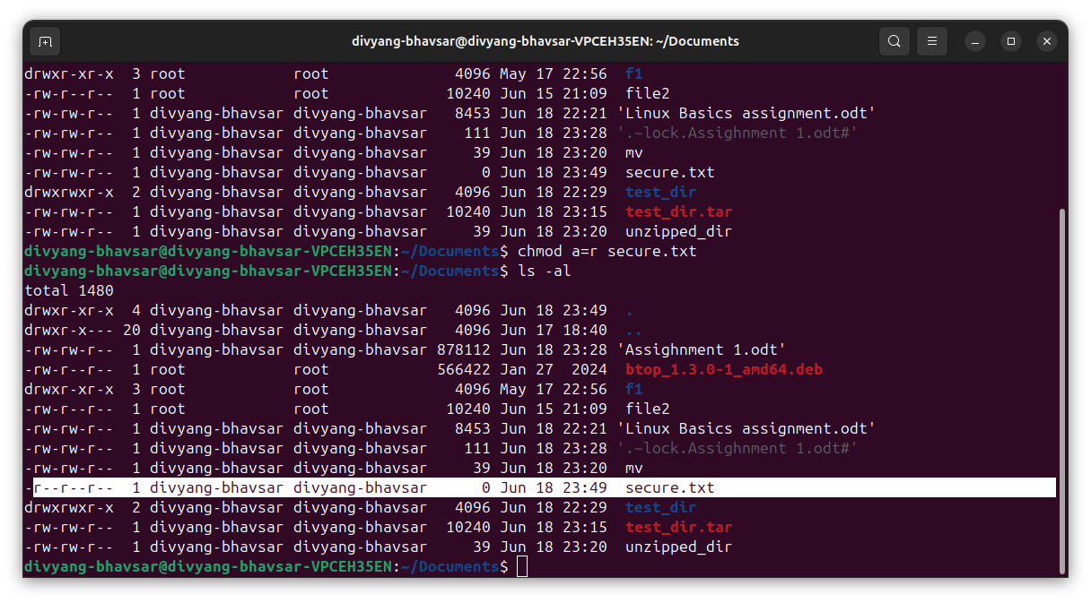

7. Working with Environment Variables

- export is used to Sets the value of an environment variable as below snapshot.

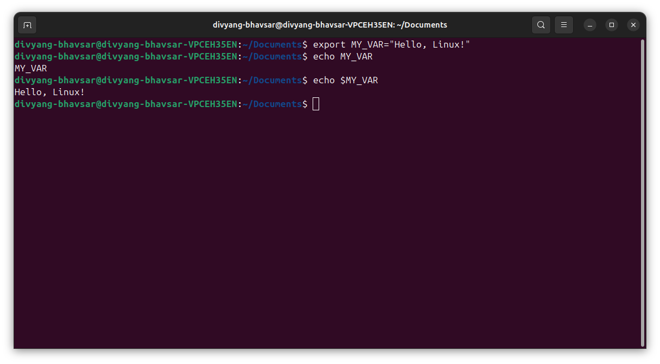

Thank You.

